Mockups for Guru99 Bank
Login Page
This page will be used for login by Manager as well as Customer
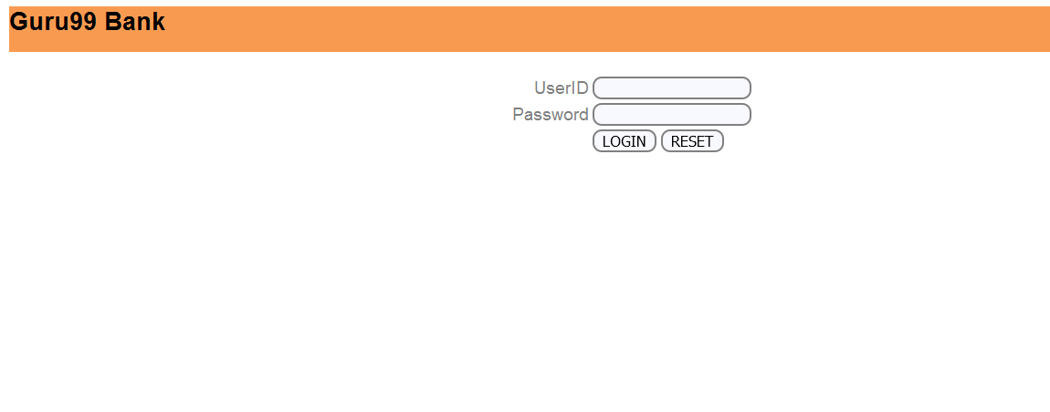

Home Page
Manager
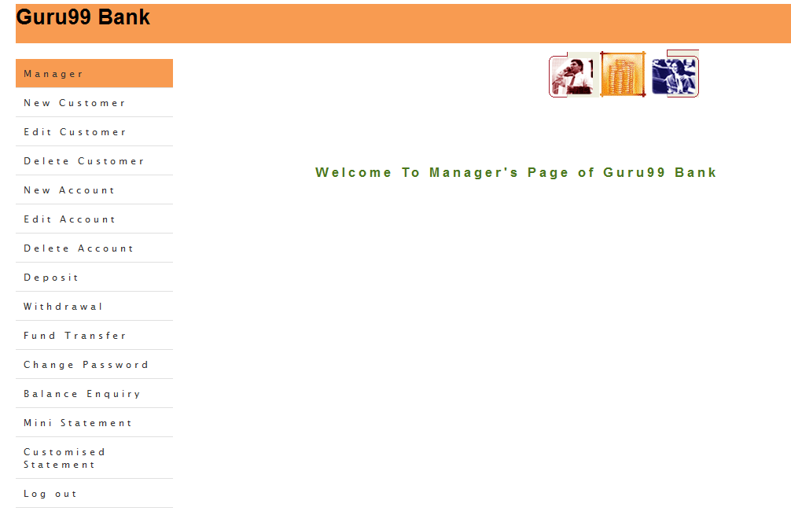

Customer
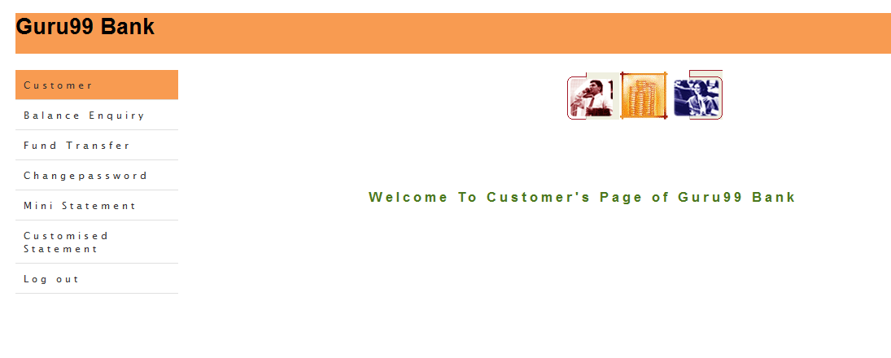

Add Customer Functionality for Manager
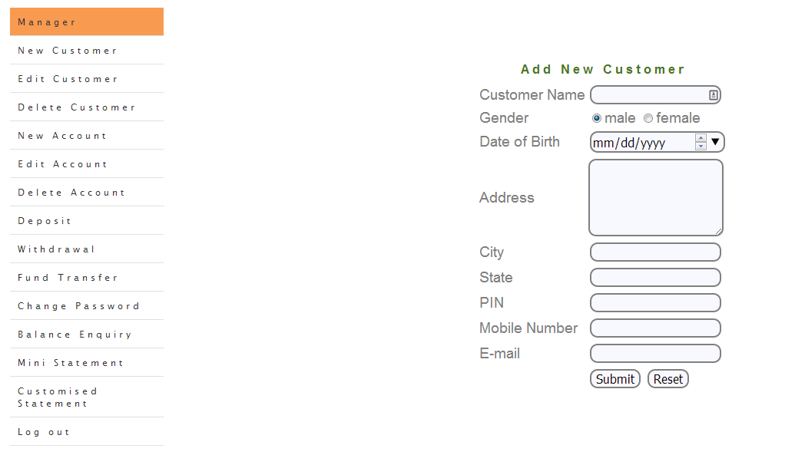

Add Account Functionality for Manager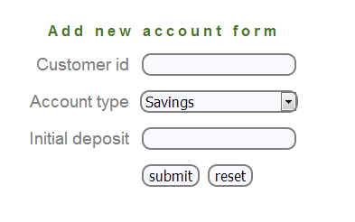
Mini Statement Functionality for Manager/Customer

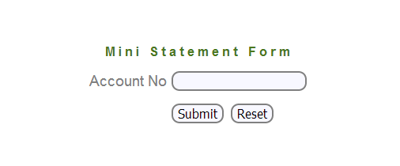
Customized Statement for Manager/Customer
